Family Development Approach – A new paradigm in Development

**DIPSHIKHA**

**Family Development Approach -Dipshikha**

Dipshikha - “Non formal Education, Training and Research Society for Village Development” was initiated in 1978 by a group of social workers, teachers and youths in the village of Rudrapur, Upazila Birol, District Dinajpur. It was registered with the Social Welfare Department in 1984 and Foreign Donation Ordinance in 1985. Dipshikha was started in a simple and modest village Rudrapur, Dinajpur and gradually its activities were expanded into 13 Upazilas of 4 districts in northern Bangladesh during last 20 years. It is working now with about 22,000 beneficiary families with envisions “A poverty free, just and peaceful society”. It believes in Integrated Development Approach, which is essentially needed to reduce the rural poverty of Bangladesh that includes formational education both for children and adults, appropriate agriculture, hygiene, sanitation, skills promotion and supports for income generation activities.

Like other NGO, Dipshikha initiated their work through *Group Based Approach (GBA)* which targets mostly the women and one person from each poor family. In Bangladesh women are targeted because they are more available, more likely to repay on time the credit, more flexible and patient than men and cheaper to service (Simanowitz, Ben, and Kasim, 2000). In GBA, Dipshikha developed a group consisting of 20 – 25 poor women in every village to promote unity and solidarity for economic emancipation as well as to get rid of social injustice. All the interventions from Dipshikha including credit activities were provided through group for its member only. Other family members are not allowed to get any intervention from Dipshikha. Another aspect to form group is to ensure effective credit repayment. The group mechanism transfers risks of non repayment from the programme to the group itself. Peer monitoring from the group members for credit repayment reduced the cost of transaction and allows for successful implementation of credit intervention through group liabilities.

Dipshikha has long experience in rural development activities through Group Based Approach. It believes in and emphasizes on self-respect and absolute human dignity. It further believes in the total development of the person i.e. human, social, cultural, economical, spiritual and political. To achieve self-reliance of individual through group activities Dipshikha found that group approach could not respond to develop the entire family of the group members. Ullah and Routray (2003) stated in their book “NGOs and Development- Alleviating Rural Poverty in Bangladesh” that today the group based approach seems to limit the magnitude of contribution of the NGO programmes has to improve poverty situation. Dipshikha experienced that the whole system is now operating on the basis of individual liabilities.

On the basis of their field experiences, Dipshikha has developed *Family Development Approach (FDA)* in 2002 in order to improve the livelihood of poor families more intensively and scientifically. Family as a social unit is considered to be the center of all development efforts. All members of the family are brought as stakeholders of the development initiatives in this approach. Dipshikha thinks that all grown up potential family members should take part in economic and social development of the family. In FDA, the member families prepare their five years development plan on the basis of their problems, resources and opportunities. Dipshikha facilitate the member families to achieve their development plan. Moreover, this plan helps the member families to use the support from Dipshikha effectively by appropriate person from the family. Further the loans are issued under this system only when the individual family can contribute 20% of the total cost of the proposed activities and repay their loans after getting income from the specific activities. Member families can use their savings to invest in their development activities.

**Why Family Development Approach?**

Development starts from needs and needs create motivation. So it can be said that motivation is the basis of development. Abraham Maslow described in his theory “Hierarchy of Needs” how these needs motivate people for their development. Abraham Maslow developed the Hierarchy of Needs model in 1940-50's and the Hierarchy of Needs theory remains valid today for human motivation and development. It described five different levels of needs such as (i) Physiological, (ii) Safety, (iii) Social, (iv) Esteem and (v) Self actualization

[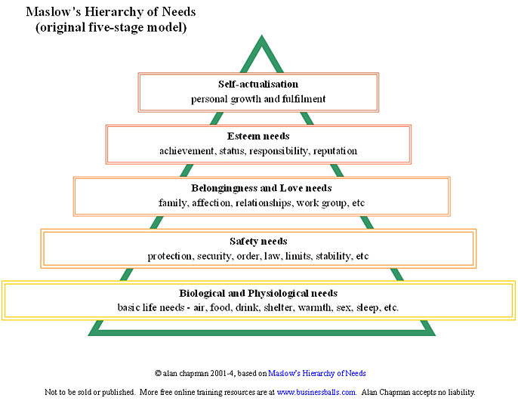](http://www.businessballs.com/images/maslow_hierarchy.htm)

Maslow's hierarchy of needs is predetermined in order of importance. It is depicted as a pyramid consisting of five levels: the lowest level is associated with physiological needs, while the uppermost level is associated with self-actualization needs, particularly those related to identity and purpose. Deficiency needs must be met first. The higher needs in this hierarchy only come into focus when the lower needs in the pyramid are met. Maslow's Hierarchy of Needs states that we must satisfy each need in turn, starting with the first, which deals with the most obvious needs for survival itself.

According to the Maslow’s theory- the development of the rural poor should start from economical development to meet the needs of food, drink, shelter, clothing etc. which belongs to 1st level physiological needs. Without money people cannot acquire all these fundamental literal requirements. People need economical development also to meet the need of safety like health protection, financial security through savings and insurance etc.

People need to be aware about different social issues like their human and social rights, heath aware for health protection, need to know different laws to get justice from different societal groups. Justice, health human rights are belongs to the level security and safety. It can be termed as social development aspect of the people.

After physiological and safety needs are fulfilled, the third and forth layer of human needs is social and esteem. Humans need to feel a sense of belonging, acceptance and recognitions. They join in different groups like clubs, office culture, [religious groups](http://en.wikipedia.org/wiki/Religion), professional organizations, sports teams etc. This level can be termed as Institutional Development.

From the above discussion the “*Development Pyramid”* can be drawn in accordance with Maslow’s theory and it is;

Development Pyramid

1. Economical Development to meet Physiological and some Safety needs:
2. Social Development for meeting Safety needs
3. Institutional Development to meet safety and social need followed by esteem need for recognitions.
4. Over all development means self- confident, self-sustain.

In Bangladesh, the development history shows that the NGOs started their development work through establishing groups of the poor people to make them united to establish rights and justice and to get available government support. Joining in a group belongs to the level three according to the Maslow’s theory and human being can not leveled over directly to the level three instead of fulfilling 1st and 2nd level of needs. Poor cannot join in a group to establish rights which belong to safety level of need theory. Poor need to earn money to satisfy the physiological needs for him and the family members. Formation of groups and maintaining the groups is less important for the poor in Bangladesh than earning money for food and other essentials. GROUP COHESION /Meetings

**Definition of FDA**

FDA is a process of empowering people through involvement of all the members of a family in development process by setting up a five years development plan in order to establish peace, justice and poverty free living condition in the society.

**Elements of FDA**

1. Development objectives /Goal/ Dream of the families
2. Family Development Plan (FDP)
3. Involvement of all the members of the family in development process
4. Open and Flexible policies

**Characteristics of FDA**

1. Need based Participatory Approach
2. Flexible
3. Each and every family formulates clear objectives to develop their family
4. All the members of the family participate in development process
5. Practice participatory decision making in the family
6. Every family prepares 3-5 years Family Development Plan on the basis of their problems, resources and opportunities in accordance to achieve the set objectives
7. Each family saves money in their home and in bank or other institutions according to achieve their development plan and to meet their crisis in the long run
8. If the families require any support from Dipshikha in order to implement their FDP, they should contribute minimum 20% of the cost of their IGA from their savings
9. Provides material/inputs support as credit instead of cash according to their FDP
10. Flexible credit repayment system according to the earning capacity of the family
11. Family repays their credit by coming in the office
12. Creates ownership, self motivation, confidence, responsibilities and own initiatives for the development of the family.

**Process of Family Development Approach:**

FDA is the combination of Individual and Group approach. On the basis of Maslow’s theory, FDA has two stages to implement the whole process:

1. Economical and Social Development of the Families
2. Institutional Development ( Formation of Association)

**Economical and Social Development Process**:

There are several steps to involve people in the Economical and social development stages;

**Family Development Workshop:**

Family development Workshop is the first step to involve the families into the development process. Dipshikha arrange two days long workshop for each and every families of the target beneficiaries in order to involve them into the development process. Generally 10 to 12 couples (mainly husband and wife) attend in one workshop. In case of the widows and divorced families their grown up son, daughter or any other member of the family who can contribute in decision making attend in the workshop.

**The main objectives of the workshop are:**

1. Identification of the poverty level of the participant families
2. Set the dream and Goal of the families
3. Preparation of 5-years development plan of the families

There are several steps to complete the workshop in a participatory way:

**Step – I : Identification of social elements**

The participants are asked how they can differentiate the poor and rich in the society. Different indicators like housing pattern, income, land ownership, type of agricultural equipments, educational qualification, number of cows own by the family, food security etc. are identified by the participants.

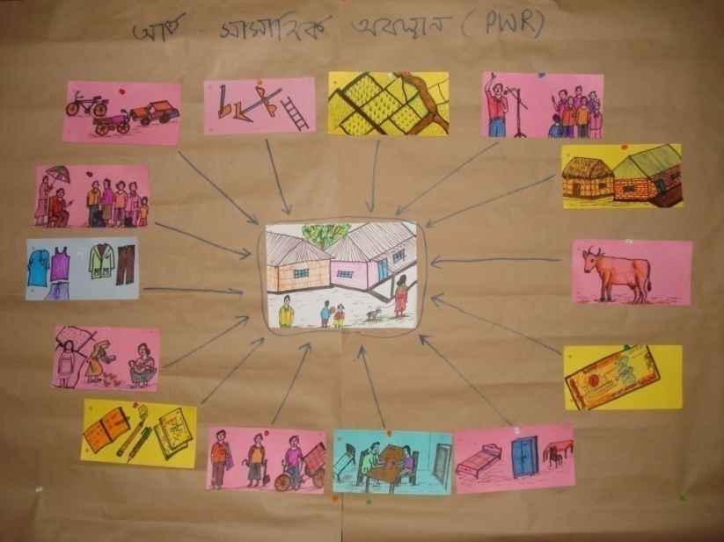

Photo: Social Elements

**Step – II : Conduct PWbR**

The participants are asked to identify the categories of families on the basis of rich and poor. Generally the categories come out from the participants are: (i) Poorest of the Poor (PP), (ii) Poor (P), (iii) Marginal Poor (MP), (iv) Middle Class (M) and (v) Rich (R). The participants select six or seven important and significant indicators among the identified indicators from social element step. They also prepare the measuring tools for the categories of the families against each selected indicator and give chronological numeric value 1, 2, 3, 4, and 5 for PP, P, MP, M and R respectively. Then the participants are asked to fit them into the categories they belong against each indicator. After wards they calculate their total marks to find out the main categories they belong.

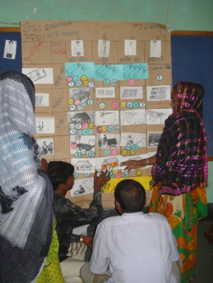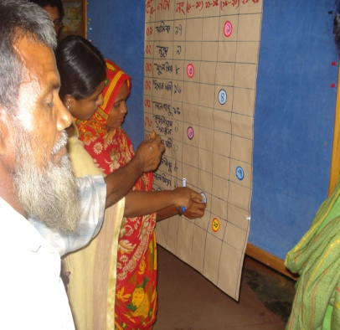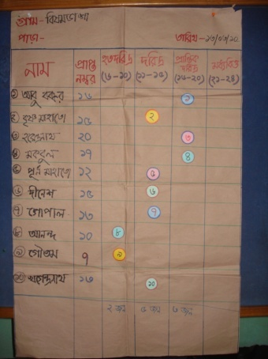

**Step – III : Identification of Causes of belongs to the Categories**

Then the participants are divided into groups according to the categories they belong. They find out the reasons, cause and effect relationship of their existing situation in order to identify the problems which they need to be address to overcome the situation.

Group Discuss

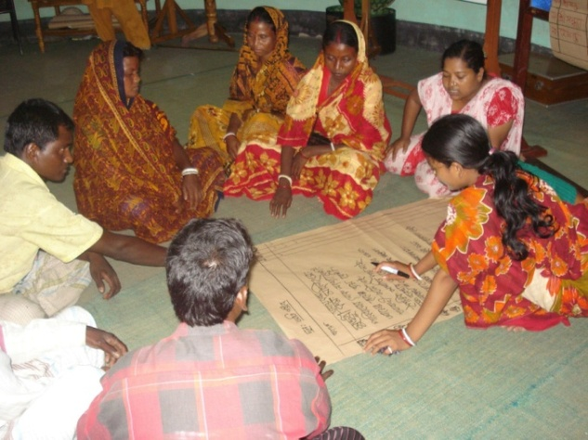

**Step – IV : Set the Dream of the Family**

The families are asked to visualize their desired situation or how they want to see their family in future or their dream on their family. After 5 minutes meditation the families are asked to draw their desirable situation on a piece of paper.

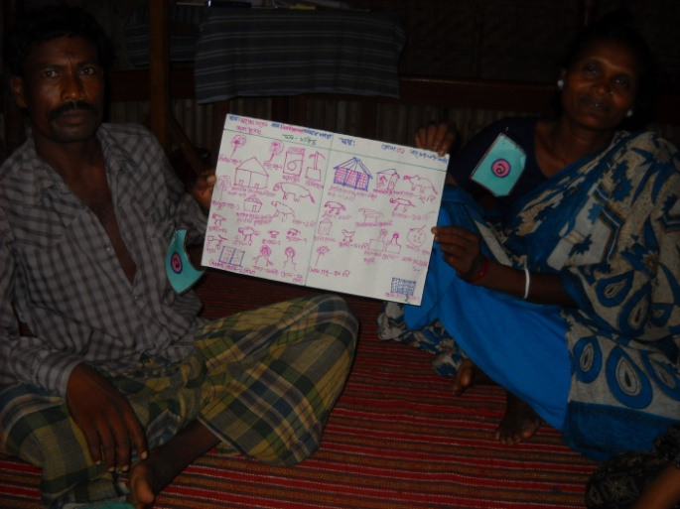

Dream of one family

**Step – VI : Prepare 5 Years Activity Plan**

The individual family prepares their five years development action plan and writes it down in a format in order to achieve the set goal. It is very important to prepare a plan of action to achieve the set goal. The possibilities of achievement of set goal are very minimum without action plan.

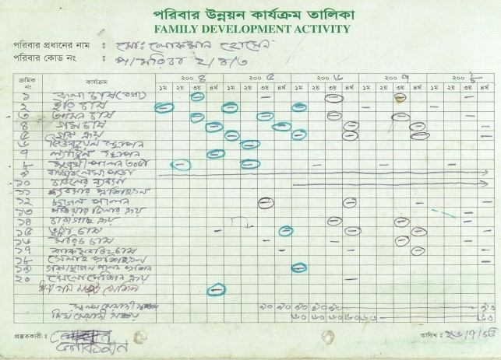

Action Plan

**Step – VII : Monitoring**

At the end of the workshop the facilitator discussed about the important and process of monitoring of their development activities and goal. The families decided to monitor the goal every after six month in order to observe their achievement.

Now the role of Dipshikha is to facilitate the families to achieve the set activities which lead them to achieve the goal. If the family achieves the goal they will be in their desire situation.

Several studies showed that different interventions from NGOs created a significant positive effect in the life of rural poor with some limitations. Ullah and Routray (2003) stated in their book ‘NGOs and Development,’ that overall household expenditure, agro productivity, knowledge on hygiene, social empowerment of the women, dependency situation on the traditional money lenders have improved in post NGO period. But major items of productive and non-productive assets, employment situation remained same as pre- NGO period. On the other hand Khandker S.R. (1999) described that microcredit have a significant and positive impact on schooling especially for boys. He also mentioned that microcredit could reduce the poverty in Bangladesh by 1 percent a year. Several study revealed that NGOs activities have a positive impact on household income as well as to access pure drinking water and sanitation. Over all housing situation is improved and women are socially empowered by almost all the indicators (Ullah and Routray, 2003). It can be concluded that the emergence of NGOs work in Bangladesh made an grate impact on the life if rural poor.

**Flow Chart of Family Development Approach**

**Base Line Survey**

**Family Selection as per fixed criteria**

**Discussion with Families**

**Family Development Workshop**

**Family Development Plan**

**Project Preparation by the Families**

**Implementation of the projects**

**Gradually Developed Families**

* **Situation Analysis (PWbR)**
* **Establishment of Dream and Goal**

**Issue Based Association**

.

**Association formation:**

Dipshikha believes people’s organization is the foundation of any sustainable development. People should take the responsibilities of their own development as well as for social development. But the questions are when and how to start the process of building people’s organization. From the long development experiences, Dipshikha further believes that without gradual development of their economical condition, poor people will not go for taking any social responsibilities appropriately. Dipshikha set two different stages/ process to assist the people towards sustainable development:

1. Economical and Social Development

2. Formation of Issue Based Associations, e. g.“Women Associations”, “Farmers Associations” etc

Dipshikha is trying to develop the socio-economic condition of the poor people through Family Development Approach (FDA), where the families are gradually taking responsibilities of their own development. It is one of the main elements of Family Development Approach. During the process of economical development, the families/people are being aware about their responsibilities in the society and about their rights as well. But families individually cannot establish their rights in the society. There are many issues need to be addressed jointly like- women issues, farmers’ rights on seeds, etc. In this regard, Dipshikha promotes to form association/organization by the people. The formation of Association should go through a participatory process, which will guide the people to be empowered. People should feel the ownership of the association and their development.

**Objectives of Formation of Association**:

1. Take over social development responsibilities by the people
2. Establish rights on different issues through involvement of mass people
3. Create net working with existing people’s organization

**Flow Chart of Association Formation**

**Decision Making Stage**

**Structure Building Stage**

**Association**

* Analysis existing condition and position of women in the society
* Identify the problems of women
* Identify the probable solution of problems
* Advantage and disadvantage of united work
* Give them work to discuss with other women in the village on learning from the workshop
* Information collection on women abusement
* Discussion with women in the villages
* Selection of Potential Women
* Invite to attend workshop

1**st Workshop**

**2nd Workshop** (After Response from Women)

* Introduction on Association and its formation
* Different Parts of an Association
* Briefing on organogram and responsibilities of different post of an association
* Give them work to set the organogram and responsibilities of their association in the village

**3rd and 4th Workshop**

**Need Assessment**

**Self Understanding Stage**

* Finalization of organogram and role of different post according to organogram
* Set the Name, Goal and Objectives
* Briefing on policies and activities
* Give them work to set the policies and activities of their association in the village
* Set the policies
* Select/elect the committee

**People Forum:**

This is final stage of Dipshikha Family Development Approach (FDA). For the sustainability of the families’ development trended and establishing their rights by playing their civil responsibilities, there is very much needed a platform and “People’s Forum” is that place. This forum formed by their own interest for the whole community in their respective area.

**Objectives of People’s Forum**

1. Awareness on civil rights and responsibilities
2. Lobbing and advocacy for the members associations
3. Networking among the rights based organizations

**Steps for People’s Forum format**

***Step-1:***

Analyze the present situation of the associations and elaborate discussion about the concept of People’s Forum to make them understand.

***Step-2:***

To grow perception about the People’s Forum its importance, structure, goal, member selection criteria and area of activities etc.

***Step-3:***

Prepare bylaws/policies finalize structure, members’ responsibilities, adhok committee and their task

People’s Forum formed by the people to establish their common rights

The People’s Forum formed from the representatives of the existing registered associations’ members at Upazila level. The main objectives of the forum are advocacy, lobbing and networking for the common and greater interest of the associations and community people. Women and Farmers’ forum formed separately in each Upazila in the project areas. They take only issue base program on the basis of their basic rights. Here is strongly mentioned that all the associations are autonomous bodies and they have separate aim and objectives. The People’s Forum acts or assists as only to achieve the associations’ objectives and programs.

area.

The following diagram shows how the forum will be acted:

People’s Forum

Representatives 3 or 4 from each association

Representatives 3 or 4 from each association

Involve community people, elite, development agencies.

Involve community people, elite, development agencies.

Family

Family

Family

Family

Family

Family

Family